**Instructions for the team.**

1. For now I have hosted the homepage in my personal Firebase account. You will be able to see that using,

<https://unipagehosting.web.app>

If needed I will be able to provide something like below for a limited amount of time (2-3 weeks)

“https://assignment.xtronic.lk”

1. If the Screen width,
   1. Less than 768px it is considered as a mobile screen
   2. Between 768px and 1024px is considered as a Tablet screen
   3. Greater than 1024px is considered as a PC screen
2. Due to Screen space limitations of Mobile screen I had to drop some details in the Footer. The Full details are available in the Tablet Screen size and PC screen size.



1. Due to the screen width limitations of mobiles and Tablets the 3 large cards on the center of the screen is acting as Horizontal scroll views. This will only be the case in mobile screens and some smaller Tablet screens. See Below



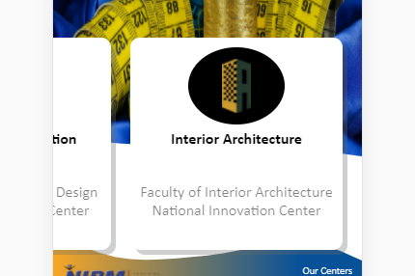

1. Regarding the Search Option in the Top Navigation Controller. Same as above 2 points due to screen width limitations all navigation options (Home, Gallery, About), Logo and the Search Bar cannot be fitted inside the Navigation Controller. Therefore a compromise had to be made. In the Mobile screen sizes the Search bar is collapsed. To Expand the Search bar and type something in it you will need to press on the Search Icon. Doing this will hide the Navigation Options except for the Logo. (Home, Gallery and About). If user didn’t type anything inside the Search bar pressing the search bar again will collapse the search bar again and the navigation options will be visible again. If not after 8 seconds the search bar will be collapse again. Another implementation that’s going on inside the Mobile screen search bar is that even if the user has typed anything in the search bar it will automatically collapse if user has not change anything inside it for 8 seconds.



For now Search options will navigate the user to the pages available in the website. (Gallery, gallery, gaLLery …. Will take user to gallery page ) Since I don’t have any specific details on how to handle anything else going on in the website I have commented the JavaScript file so that other use cases will be able to handle there. In line 190 you will be able to handle the rest of the use cases if there is any.

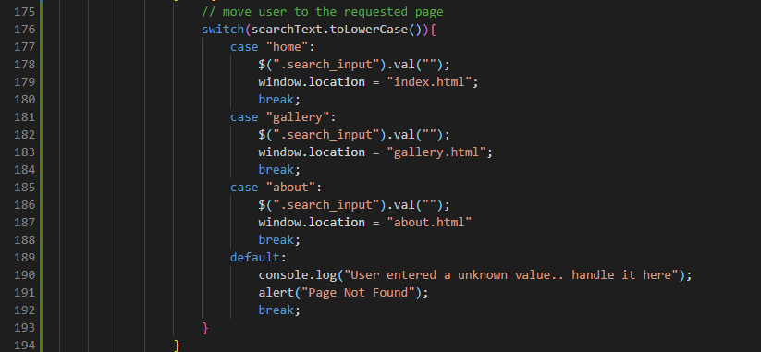

There will be no such timeouts or collapsing events happening in the Tablet screens and PC screens because they are big enough to handle full width of the search bar. In Tablet and PC screens search bar will behave as user expects it to.

1. One small thing the Logo you have provided to put in the Navigation controller was 500px*500px but the in order to fit it in it needed stay inside a 100px*100px. The scaling down of the image is automatically handled by the HTML. But it loses lots of details. Here are some suggestions that you can do.
   1. Choose a different Logo (without letters preferably) with less details. So that scaling down will not lose anything.
   2. Scale down the current image in Photoshop to 100px*100px and see whether that looks good and that is acceptable send it so that I can use that.
   3. Remove the logo from the navigation controller altogether. So that the Navigation controller will only have navigation options (Home, Gallery and About) and the search bar.
2. Background image change is handled partially from CSS file and partially from JavaScript. Be careful when editing the files.
3. Search bar related implementation and navigation related code is done inside the JavaScript file using JQuery.
4. To add or remove styling from the web page use the styles.css file. DO NOT CHANGE ANYTHING FROM styles.scss
5. Check for Bugs in the UI and let me know. If there is anything that needs to be changed let me know. I will do that ASAP.
6. All the files you have shared in the Google Drive is inside the “docs” folder of this project.
7. All the images I used in the projects are in the “img” folder.
   1. Background images used in the website is in the “background” folder
   2. Other Images appear in the webpage is located in the “UI_Elements” folder
8. For testing purposes I have added about.html and gallery.html files in the project as well. ( to test pressing on navigation options or using search options will take the user to the appropriate page ) You will need to replace the files using your files
9. The css file and the JavaScript files used in the project are inside the appropriate folder ( styles.css is inside the “css” folder and index.js file is inside the ‘js’ folder )
10. Both .docx and the .pdf file of this document will be saved inside the “docs” folder as well.
11. If someone need the project files it will be able to be downloaded from,

https://github.com/Omegaki113r/UniversityPortfolioHomePage.git